**Decidability**:

A problem is said to be decidable if there exists a Turing machine which gives one

‘yes’ or ‘no’ answer for every input in the language.

(or)

A problem is said to be decidable if it is a recursive language.A language is called Decidable or Recursive if there is a Turing machine which accepts and halts on every input string w. Every decidable language is Turing-Acceptable.

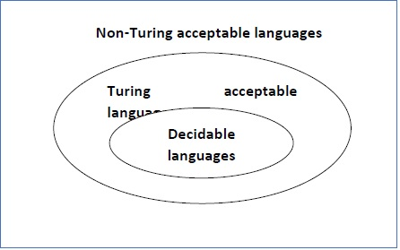

A decision problem P is decidable if the language L of all yes instances to P is decidable.

For a decidable language, for each input string, the TM halts either at the accept or the reject state as depicted in the following diagram –

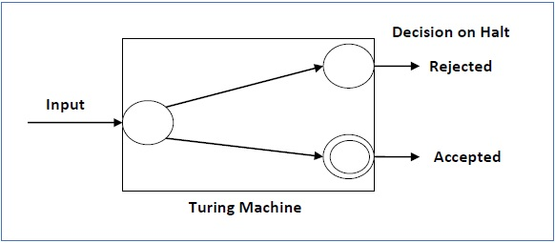

Example 1

Find out whether the following problem is decidable or not −

Is a number ‘m’ prime?

Solution

Prime numbers = {2, 3, 5, 7, 11, 13, …………..}

Divide the number ‘m’ by all the numbers between ‘2’ and ‘√m’ starting from ‘2’.

If any of these numbers produce a remainder zero, then it goes to the “Rejected state”, otherwise it goes to the “Accepted state”. So, here the answer could be made by ‘Yes’ or ‘No’.

Hence, it is a decidable problem.

Example 2

Given a regular language L and string w, how can we check if w ∈ L?

Solution

Take the DFA that accepts L and check if w is accepted

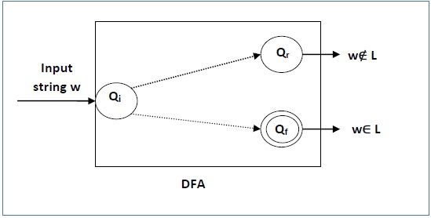

If a language L is decidable, then its complement L' is also decidable

If a language is decidable, then there is an enumerator for it.

For an undecidable language, there is no Turing Machine which accepts the language and makes a decision for every input string w (TM can make decision for some input string though). A decision problem P is called “undecidable” if the language L of all yes instances to P is not decidable. Undecidable languages are not recursive languages, but sometimes, they may be recursively enumerable languages.

